A000-Afr-Dogon-Nyerum water spirit-Wood-19th c

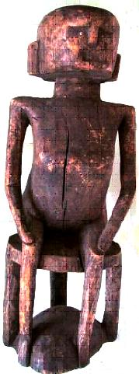

*Nyerum*, Female Water Spirit

**Case no.:**

**Accession Number:**

**Formal Label:** Dogon-Nyerum water spirit-Wood-19th c

**Display Description:**

* *Nyerum* is a cosmic force, seated on a stool that consists of two discs, the upper one, the seat, represents the sky, and the other, the platform, the earth.
* Sky and earth are connected by three supporting aniconic posts symbolizing *Nommo*, a subsidiary male spirit who controls the amount of water in wells.
* Among the Dogon stools are objects of prestige that define social status, but here it the stool defines cosmic status.
* *Nyerum* would have been placed in a shrine near the source of drinking water to whom prayers were made in order to insure *access* to an adequate supply of potable water.
* However *Nyerum* could also lure the unsuspecting into the deep water holes and drown them if they transgressed.
* This is another case of illustrating by popular myth the objective danger of natural forces and was especially geared to children whose responsibility it was to retrieve water for the family.
* However, the children learned that they were protected by the crocodile spirit but those adults who might abuse their use of the watering hole must answer to Nyerum without crocodile’s intercession.

**LC Classification:**

**Date or Time Horizon:**

**Geographical Area:**

**Map:**

**GPS coordinates:**

**Cultural Affiliation:**

**Media:**

**Dimensions:**

**Weight:**

**Condition:**

**Provenance:**

**Discussion:**

**References:**